
Contestant Number:
Time:
Rank:

FUNDAMNENTAL SPREADSHEET APPLICATIONS
(230)

STATE - 2020

Production Portion:

Job 1: Create Spreadsheet with Formulas (160 points)
Job 2: Format Spreadsheet (70 points)
Job 3: Create Chart (70 points)

TOTAL POINTS (300 points)

Failure to adhere to any of the following rules will result in disqualification:
- Contestant must hand in this test booklet and all printouts. Failure to do so will result in disqualification.
- No equipment, supplies, or materials other than those specified for this event are allowed in the testing area. No previous BPA tests and/or sample tests or facsimile (handwritten, photocopied, or keyed) are allowed in the testing area.
- Electronic devices will be monitored according to ACT standards.

No more than ten (10) minutes orientation
No more than ninety (90) minutes testing time
No more than ten (10) minutes wrap-up
Property of Business Professionals of America.
May be reproduced only for use in the Business Professionals of America
Workplace Skills Assessment Program competition.

GENERAL INSTRUCTIONS
- Make certain this test booklet contains Jobs 1-3.
- Key all jobs according to the instructions given.
- Correct any obvious keyboarding errors and incorporate any editing notations.
- Correct any errors in formatting. Use formatting shown in the Style & Reference Manual.
- For any problem where you would normally key your reference initials, key your contestant number. Your name or initials should not appear on any work you submit.
- Key your contestant number and job number as the footer in the lower left-hand corner of all work submitted unless otherwise specified.

Example:
99-9999-9999
Job 1

- If you finish before the end of the testing time, notify the proctor. Time may be a factor in determining a winner when there is a tie score.
- When turning in your materials, place your scoring sheet on top of your jobs. The jobs should be arranged in numerical order. Turn in all partial jobs completed
- Center all worksheets vertically and horizontally to print on one page.
- Print all worksheets in Landscape format.
- Print each chart on a separate sheet.
Scenario

Your organization is presenting to a group of eighth graders about careers. Your part of the presentation is creating the spreadsheet comparing wages between different education levels. Using the information you gathered from Bureau of Labor Statistics create the following spreadsheet.

Job 1 (Worksheet with formulas) | Points Possible | Points Earned
Contestant # and Job # in left section of footer | 5
12 pt. Times New Roman font used for data | 5
Inserted Row before high school graduate and entered: high school dropout; 13.83; | 5
Inserted Row before college graduate and entered: some college, no degree; 20.05; | 5
Update cells (5 points each):  - A14 and A19: High School dropout and graduate  - A15 and A20: High School graduate and 2 year graduate  - A16 and A21: 2 year college graduate and a 4 year graduate | 15
Used PAY_PER_HOUR and HOURS in formula in cell C4 that calculates gross pay; Formula filled down for all other education levels | 10
Used TAX_RATE in formula used in cell D4 to calculate the net pay after taxes; Fill formula down for all other education levels | 10
E4 formula for gross pay for 2 weeks; fill the formula down for the other education levels | 10
F4 formula for gross pay for a month; fill the formula down for the other education levels | 10
Cell B14 create a IF function calculating the difference between high school dropout and high school graduate | 10
Cell B15 create a IF function calculating the difference between high school graduate and 2 year graduate | 10
Cell B16 create a IF function calculating the difference between 2 year graduate and 4 year graduate | 10
Cell B19 create a formula calculating the difference in yearly salary between high school dropout and high school graduate. | 10
Cell B20 create a formula calculating the difference in yearly salary between high school graduate and 2 year graduate | 10
Cell B21 create a formula calculating the difference in yearly salary between 2 year graduate and four year graduate | 10
Column widths adjusted to see all data | 5
Print out is landscape, centered vertically and horizontally, on one page, with gridlines and headings | 10
Print out of formulas in landscape view with the worksheet centered on ONE page with gridlines and headings | 10
Subtotal | 160

Job 2 (Formatted worksheet) | Points Possible | Points Earned
Contestant # and Job # in left section of footer | 5
Printed in landscape, centered vertically and horizontally on one sheet | 10
B4:F11; B13:B16; and B19:B21 currency with 2 decimal places (5 points each range) | 15
A1:F1: merge and center across the spreadsheet, bold, font size 18 | 5
A3:F3: center and bold | 5
A13:B13 and A18:B18: merge and center and bold | 5
A14:A16 and A19:A21: right align | 5
Row 3 has Text Wrap applied | 5
Column width A is 50pts and Columns B:F are 12pts wide | 5
Shading applied to A3:F3, B13, and B18 | 5
Thick outside border around cells A1:F11, A13:B16, and A18:B21 | 5
Subtotal | 70

Job 3 (Clustered Column Chart) | Points Possible | Points Earned
Contestant # and Job # in left section of footer | 5
Correct Clustered Column Chart created on its own sheet | 15
Printed on full sheet, landscape in Black & White | 10
Correct title entered | 10
Format chart to style 2 | 5
Format chart to layout 1 | 5
Legend Removed | 10
Data Callout Data Label style | 10
Subtotal | 70
TOTAL POINTS | 300

JOB 1: Create Spreadsheet with Formulas

- Enter the following data into an Excel spreadsheet like shown below and complete the calculations as instructed. Use Times New Roman size 12 font and landscape orientation.

2018 EARNING POWER BASED ON EDUCATIONAL LEVEL
EDUCATION LEVEL | PAY PER HOUR | GROSS PAY | NET PAY AFTER TAXES | GROSS PAY FOR 2 WEEKS | MONTHLY GROSS PAY
High School Graduate | 18.25
2-Year College Graduate (Associates Degree) | 21.55
4-Year College Graduate (Bachelor's Degree) | 29.95
Master's Degree | 35.85
Professional Degree | 47.1
Doctoral Degree | 45.63
Difference in net pay for the week between:
Differences in yearly net pay between:

- You have decided to update the spreadsheet with more education levels, insert a row above high school graduate and enter the following information:
- High School Dropout; 13.83 pay per hour.

- You have decide to update the spreadsheet with more education levels, insert a row above 2 year college graduate and enter the following information:
- Some college, no degree; 20.05 pay per hour.

- Update the spreadsheet with the following information based on cell reference provided.
- A14 and A19: High School dropout and graduate
- A15 and A20: High School graduate and 2 year graduate
- A16 and A21: 2 year college graduate and a 4 year graduate

- Define the following named ranges and constants:
Name of Range | Value/Range
PAY_PER_HOUR | B3:B11
TAX_RATE | 0.18
HOURS | 40
- Using the PAY_PER_HOUR and HOURS defined names, create a formula in cell C4 that calculates the gross pay and fill the formula down for all of the other education levels.

- In cell D4 create a formula to calculate the net pay after taxes and fill the formula down for all of the other education levels.

- In cell E4 create a formula that calculates the gross pay for 2 weeks and fill the formula down for all of the other education levels.

- In cell F4 create a formula that calculates the gross pay for a month (4 weeks) and fill the formula down for all of the other education levels.

- In cell B14 create a function that shows the difference if high school dropout is greater than high school graduate, then subtract high school graduate from high school dropout. If not, then subtract high school dropout from high school graduate.

- In cell B15 create a function that shows the difference if high school graduate is greater than 2 year graduate, then subtract 2 year graduate from high school graduate. If not, then subtract high school graduate from 2 year graduate.

- In cell B16 create a function that shows the difference if a 2 year college graduate is greater than 4 year graduate, then subtract the 4 year graduate from 2 year graduate. If not, then subtract 2 year graduate from 4 year graduate.

- In cell B19, create a formula that finds the difference in yearly salary between high school dropout and high school graduate.

- In cell B20, create a formula that finds the difference in yearly salary between high school graduate and 2 year graduate.

- In cell B21, create a formula that finds the difference in yearly salary between 2 year graduate and 4 year graduate.

- Adjust column widths, as needed so all information shows.

- Print a copy of the worksheet vertically and horizontally centered in landscape view to one page with gridlines and headings.

- Print a copy of the worksheet showing the formulas vertically and horizontally centered in landscape view scale to one page with gridlines and headings. BE SURE THAT ALL FORMULAS ARE FULLY VISIBLE.

JOB 2: Format the Spreadsheet you created in Job 1 using the following instructions:

- Format B4 F11; B13:B16; and B19:B21 as currency with 2 decimal places.
- Format the following information:
- A1:F1: merge and center across the spreadsheet, bold, font size 18
- A3:F3: center and bold
- A13:B13: merge and center and bold
- A14:A16: right align
- A18:B18: merge and center and bold
- A19:A21: right align
- Enable Wrap Text in Row 3.
- Set Column A width to 50 points and Columns B:F to 12 points.
- Apply shading of your choice to A3:F3, B13, and B18.
- Place a thick outside border around cells A1:F11, A13:B16, and A18:B21.
- Print out the formatted spreadsheet with it centered horizontally and vertically on one page.
JOB 3: Create a Clustered Column Chart.
Create a chart from the spreadsheet you have created in the previous jobs showing the differences between the pay per hour. It should be moved to its own sheet. Change the sheet name to Pay Per Hour Breakdown.
Format the chart to look like the following:
- Format chart to style 2.
- Format chart to layout 1.
- Title is size 24 font. Title the chart: Pay Per Hour Breakdown.
- Remove Legend
- Apply Data Callout Data Labels
- Print out on a full sheet in Black & White.

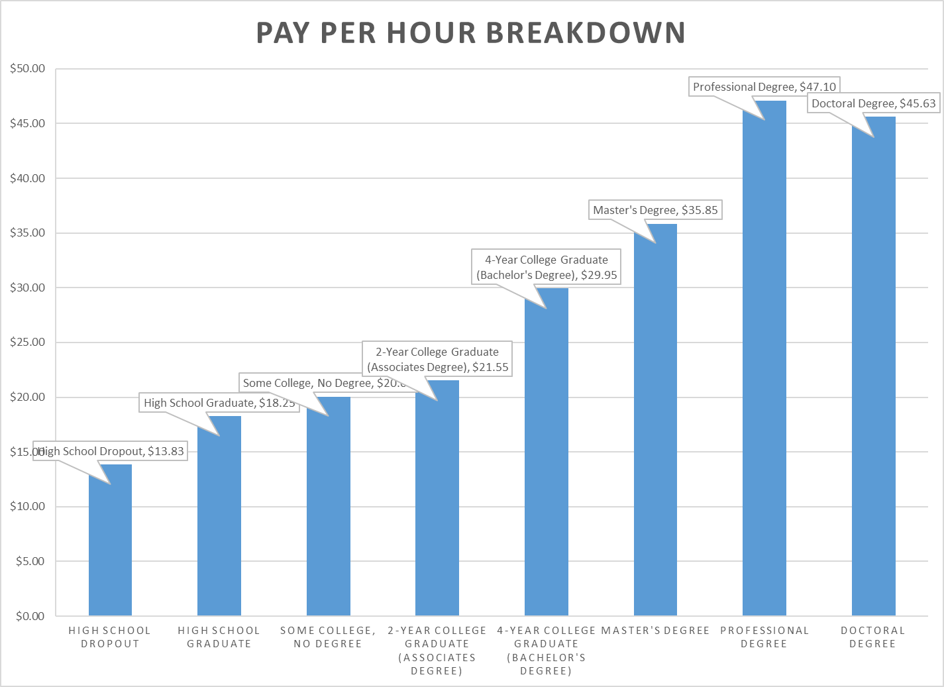

You should have the following four printouts:
Job 1—unformatted
Job 1—formulas
Job 2—formatted
Job 3—clustered column chart

